# Guided Lab - 304.2.2 -

# Download “Classicmodels” Database

# 

## Lab Overview:

## In this lab, we will demonstrate how to load the MySQL sample database into the MySQL database server using MySQL Workbench. After this lab, you will have the classicmodels sample database loaded onto MySQL for practicing and MySQL.

## Lab Overview:

At the end of this lab, learners will be able to use MySQL Workbench to load the MySQL database into the MySQL database server.

**Instructions:**

### **Step 1.** Download the classicmodels database.

[**Click here to download the database script file**](https://drive.google.com/file/d/1JoT6N-kNhJ048ahXvvSgWNE0737NAdbb/view?usp=sharing).

*The classicmodels.sql file will be downloaded to your computer.*

### **Step 2.** Launch the MySQL Workbench application as shown below.

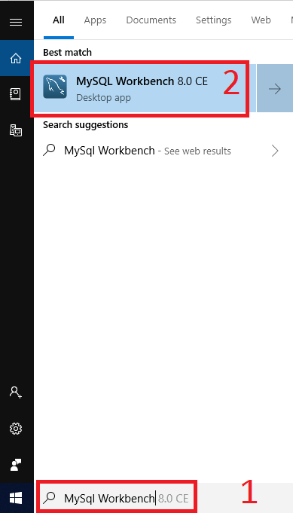

### **Step 3.** To add a new database connection for querying, click on **Local Instance MySQL57** as shown in the screenshot:

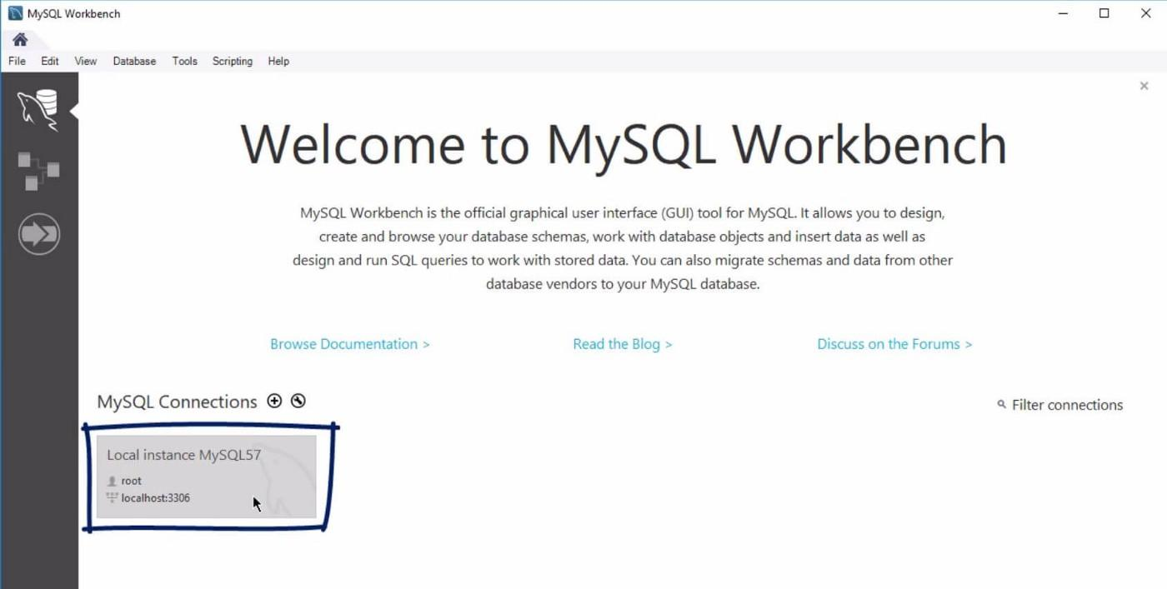

### **Step 4:** MySQL will ask us to enter the password for the **root** account. We enter our password here and click the **OK** button as shown in the screenshot.

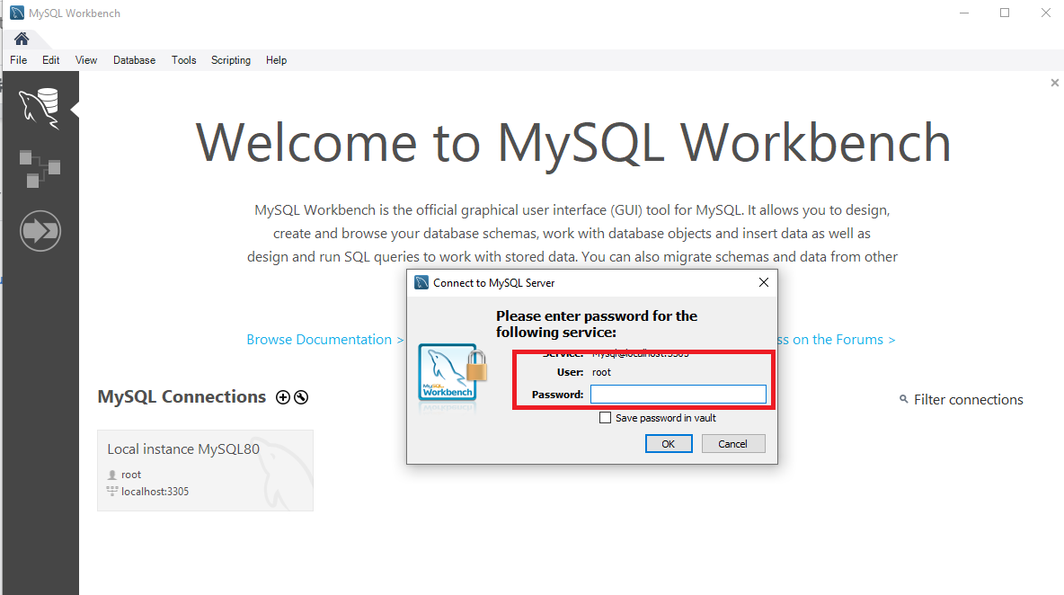

Note: If you enter both the **username** and **password** correctly, you will see the following window:

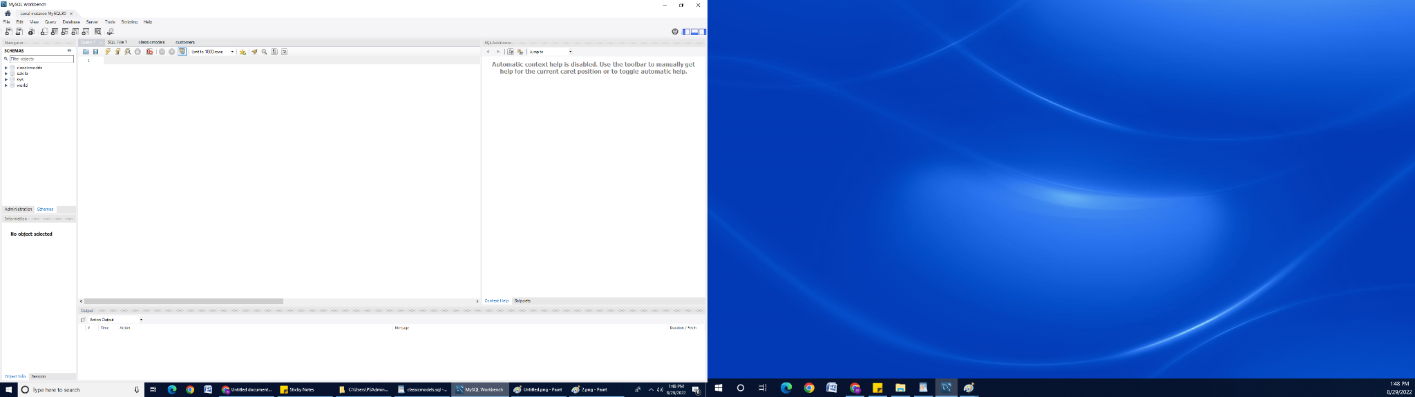

### **Step 5.** Open SQL Script by choosing **File > Open SQL Script** or press the **Ctrl+Shift+O** keyboard shortcut.

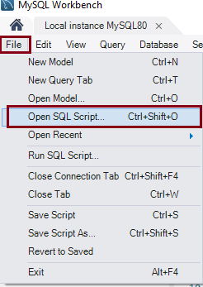

### 

### 

### **Step 6.** Choose the SQL Script file by selecting the File. Click **Open**.

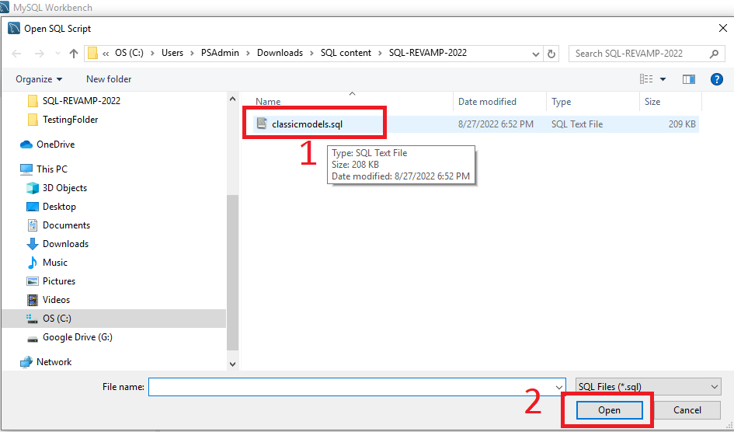

### **Step 7.** To execute a SQL script, click on the **Execute** button from the toolbar as follows:

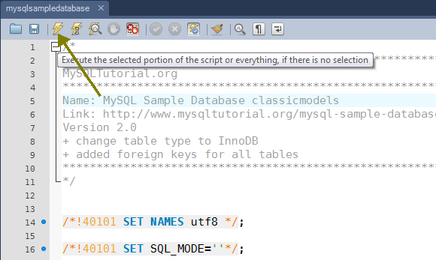

## 

### **Step 8.** Right-click inside the **Schemas** panel and click the **Refresh All** button to update the panel.

## 

## 

## 

## The classicmodels database is loaded successfully into the MySQL server.

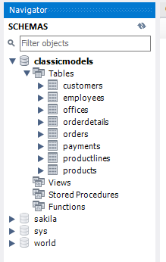

# 

# Schema Diagram of the “Classicmodels” Database:

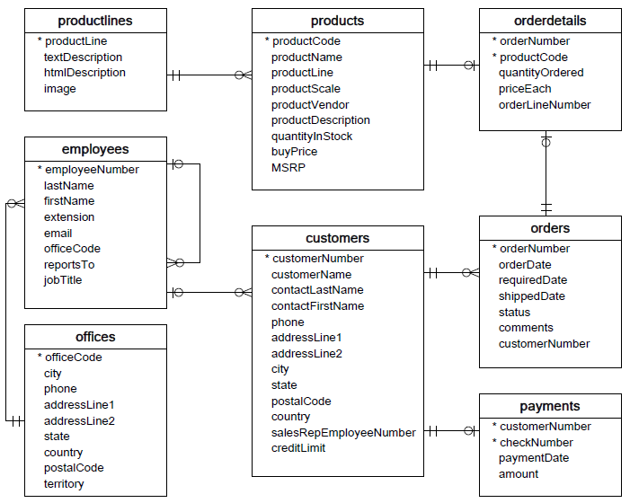

The classicmodelsdatabase is a retailer of scale models of classic cars database. The classicmodels sample database schema consists of the following tables:

* Customers: stores customer’s data.
* Products: stores a list of scale model cars.
* ProductLines: stores a list of product line categories.
* Orders: stores sales orders placed by customers.
* OrderDetails: stores sales order line items for each sales order.
* Payments: stores payments made by customers based on their accounts.
* Employees: stores all employee information, as well as the organization's structure, such as who reports to whom.
* Offices: stores sales office data.

## 

**Canvas submission Instructions:**

Please include the following deliverables in your submission -

* + All queries should be written and submitted in a single SQL script file.
    - Example: **<your_name_labname>.sql**.
  + **Please do not add the questions in your SQL script file.**
  + Submit your SQL script file using the **Start** **Assignment** button in the top-right corner of the assignment page in Canvas.

**CANVAS STAFF USE ONLY: Canvas Submission Guideline:**

| **Instructions for Canvas Assignment Creation** |
| --- |
| **Assignment Name: GLAB - 304.2 - Download “Classicmodels” Database**  **Points:** **100**  **Assignment Group: Module 304 - Relational Databases and SQL - (Not Graded)**  **Display Grade As: Non-graded (This assignment does not count toward the final grade.)**.  **Complete/Incomplete**  **Do not count this assignment towards the final grade: Checked**  **Submission Types:Files Uploads**  **Everything else is the default.** |